Application Insights: enable and investigate
  - Portal-first beginner hands-on lab
LBS | Attendee edition v2 | 26 October 2026

Before you start
Environment: use the instructor-approved sandbox, group, region, tiers and spending limit. Create only your own disposable resources. The walkthrough uses fictional data. No cloud resource is created by reading this document.
Materials: copy Labs\AppServiceSqlSample locally when the lab needs the .NET sample. Complete its setup from 02_Windows_And_Local_SQL_Setup.docx. Do not repeat resource creation if you already completed the same lab in the main guide.
Admin assistance: Contributor does not automatically grant IAM role assignment, SQL SELECT, Blob data access or Service Bus data access. Have the authorised administrator perform only the privileged step. Never bypass policy.
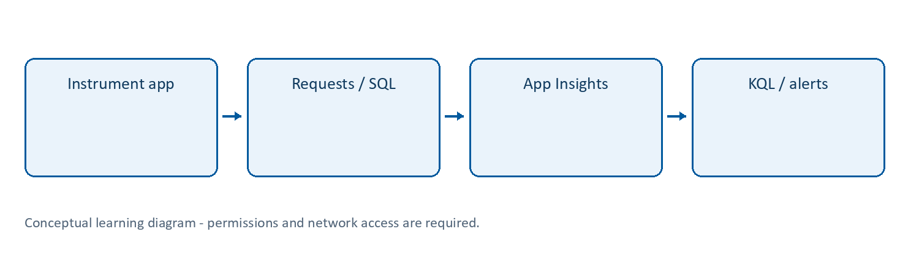
Learning flow

Application Insights | Understand application behaviour
What: Azure Monitor’s application performance monitoring experience. Instrumented applications produce requests, dependencies, traces, exceptions and other telemetry. Application map and performance/failure views help investigate it.
Why/when: answer “which endpoint failed?”, “was SQL slow?”, and “what changed after deployment?” Logs alone without request/dependency correlation are often insufficient.
How: create/select a workspace-based resource; enable one supported instrumentation path; generate traffic; inspect the portal views and stored telemetry. Follow Lab 7.
Example: an API request has a slow SQL dependency; a Function invocation fails because it cannot read a blob.
Tips and traps: setting a destination connection string does not by itself instrument arbitrary code. Do not enable competing SDK/agent paths without checking compatibility. Sampling and ingestion delays affect what you see. Never log raw documents, tokens or sensitive fields. Check destination resource, role name, time window and actual telemetry schema before deciding an empty graph means healthy.
Reference: https://learn.microsoft.com/azure/azure-monitor/app/app-insights-overview

Lab 7 | Application Insights and Log Analytics (core)
Time: 45 minutes. Needs: deployed app from Lab 3 or instructor-provided instrumented app. Cost: telemetry ingestion/retention and any alerts.
- Search Log Analytics workspaces > Create. Use law-lbs-<suffix>, the training group and approved region, unless Lab 3 already created the assigned workspace. Do not create a duplicate.
- Search Application Insights > Create and select the workspace from step 1, unless the assigned resource already exists. Use ai-lbs-<suffix>.
- On App Service open Application Insights > Enable and select this resource. Choose recommended monitoring for supported ASP.NET Core auto-instrumentation, then apply. The app restarts.
- This guide uses Windows App Service and a supported .NET LTS stack. If auto-instrumentation is unavailable, the instructor must supply an instrumented build using the supported Azure Monitor SDK/OpenTelemetry route. Do not assume a connection-string setting alone instruments application code.
- Avoid enabling a second instrumentation path on an already instrumented app; duplicate telemetry can result.
- Open the deployed API and /health repeatedly, or generate a small, bounded set of requests from PowerShell:
$baseUrl = "https://<actual-web-app>.azurewebsites.net"
1..10 | ForEach-Object {
Invoke-RestMethod "$baseUrl/health"
Invoke-RestMethod "$baseUrl/api/items"
Start-Sleep -Seconds 1
}
- Check Application Insights > Live Metrics, Failures, Performance and Application map. Live Metrics and stored logs may appear at different times. Allow several minutes for ingestion.
- Open the Log Analytics workspace > Logs and switch to KQL/query editor mode if needed. Use that workspace context for the next lab.
- Review workspace Usage and estimated costs and retention. Discuss instructor-approved daily caps/retention, but do not disable required monitoring or treat a cap as a guaranteed immediate billing stop.
Checkpoint: request rows appear in AppRequests for the web app. SQL dependency visibility depends on supported instrumentation and the executed query path; verify it rather than assuming it exists.

7A. Create and test a failure alert (hands-on)
- In Azure Monitor > Alerts > Action groups > Create, use your training group and a short display name. Add only an approved email recipient for yourself/instructor.
- Review and create, then use the action group’s Test feature. Confirm the test email arrives; this tests notification delivery, not query-condition firing.
- From the Log Analytics workspace choose Alerts > Create alert rule, then a Custom log search condition.
- Use the following query, substituting your actual Application Insights resource ID so a shared workspace does not alert on other apps:
AppRequests
| where TimeGenerated > ago(15m)
| where _ResourceId =~ "<actual-application-insights-resource-id>"
| where Success == false
- Configure table-row count greater than 0, a 15-minute lookback and an instructor-approved evaluation frequency such as 5 minutes. Do not split dimensions for this introductory exercise.
- Select the action group and a clearly named low-impact training alert. Review the alert’s pricing and permissions before creating.
- Generate the single approved failure in Lab 8F, restore the app immediately, and wait for ingestion/evaluation. Confirm an actual fired alert separately from the action-group test. A 404 may not meet this application’s Success == false semantics, so use recorded telemetry rather than guessing.
- Inspect the alert instance, query result and time window. Disable/delete the training alert after verification to avoid ongoing evaluation charges and emails.
Checkpoint: action-group test received; real alert fired or the exact evaluation/telemetry blocker documented. Do not count a test email alone as successful application failure detection.

Lab 22 | App metrics, restart and Azure health
What/why: compare application health, platform metrics and Azure service incidents.
Needs: disposable working App Service from Lab 3. Restart only your own app; no shared-service outage exercise.
- Open App Service > Monitoring > Metrics. Choose an available request count metric and a recent time range.
- Inspect supported dimensions/aggregation; choose Total for a count if offered. Do not compare Average and Total as equivalent.
- Send a small bounded batch of /health and /api/items requests as in Lab 7. Wait for metric updates.
- Compare the platform metric with Application Insights stored request rows. Sampling, scopes, aggregation intervals and telemetry paths can differ.
- Check Health check configuration if supported by the chosen tier and confirm the configured path. Remember this sample’s /health does not query SQL.
- Record a successful database response, then use Overview > Restart on your disposable app. Wait for restart and retest both endpoints.
- Inspect Activity log for the management restart and Log stream for application startup where available. The two sources prove different facts.
- Open Service Health from portal search. Inspect active service issues and planned maintenance affecting permitted subscriptions, or record that none are shown. Then inspect Resource health for your app where offered.
- Explain why an individual app exception can occur with no regional Azure incident, and why Resource Health alone does not prove business functionality.
Expected: app recovers after restart and SQL response remains correct; metric and log scopes are explained.
Cost: do not scale up/out merely to populate a graph; existing plan charges remain. Security: use fictional traffic; do not generate load tests without permission. Cleanup: no new resources; stop only unwanted local copies.
Reference: https://learn.microsoft.com/azure/service-health/overview

Completion record and cleanup
Record | Your observation
Subscription/group/region and actual resource names
Expected result and actual result
Log/table/metric, time range and evidence
Identity, role/scope and network restrictions
Idle/usage/logging cost driver
Cleanup or retention owner/deadline
Only mark a lab passed after its functional checkpoint. A deployment success or empty error table alone is not proof. Mark blocked permissions honestly.
Clean up only your own disposable objects; removing a diagnostic setting does not erase retained logs, and stopping an app does not stop every cost. Follow Lab 13 in the main guide. Keep secrets/customer information out of evidence.
Verification scope: these instructions and Word file structure were reviewed. Automated Word pagination could not be completed; preview before printing. Azure execution, prices, policy, permissions, plan/runtime availability and portal labels require instructor rehearsal in the actual training subscription.

